****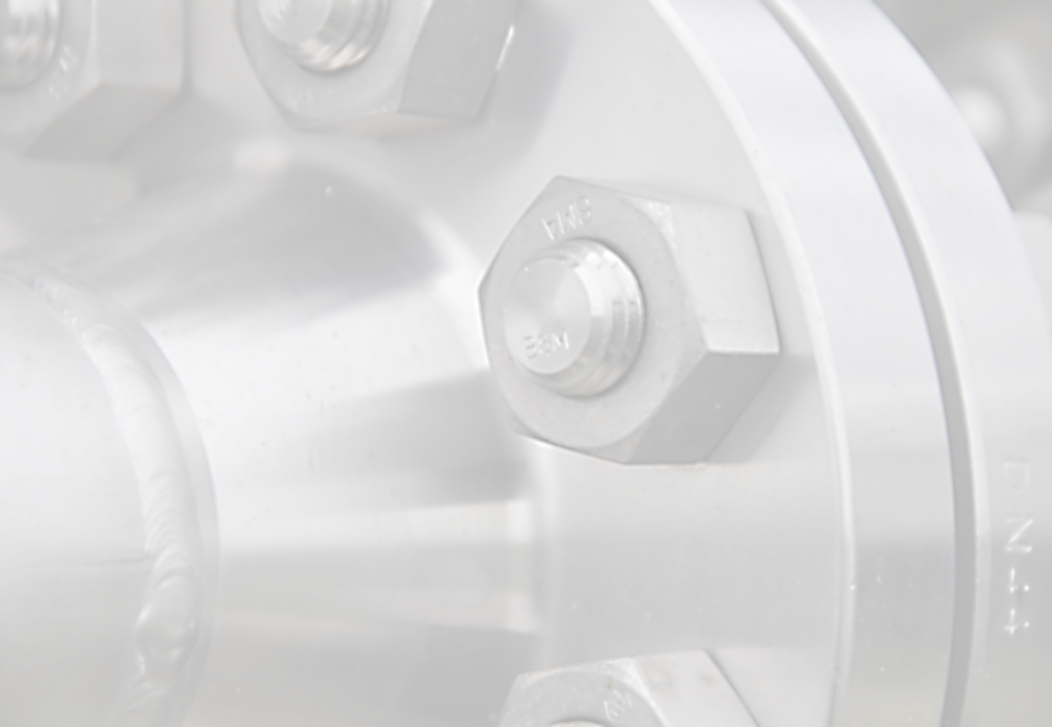

**EUIPO Study on**

**“*The Baseline of Trade Secrets Litigation in the EU*"**

**-** Data gathering questionnaire -

**INDEX**

**Section I: General information on trade secrets**

1. Jurisdiction
2. Preservation of trade secrets during litigation
3. Trade secrets holders’ perception
4. Additional information

**Section II: Information on trade secrets single cases**

1. Court
2. Overall applicant and respondent’s profile
3. Object of disputes
4. Data on disputes
5. Cross-border issues
6. Remedies, measures sought/granted
7. Trade secrets holders’ reactions to alleged cases of misappropriation

| **TOPIC** | **QUESTION** |
| --- | --- |
| **Section I: General information on trade secrets** | |
| 1. Jurisdiction | 1.1. What is the definition of “trade secret” according to your jurisdiction? |
| Please provide the following information:  1.2. Source of law for trade secret protection  1.3. Scope of the available protection  1.4. Related effectiveness  1.5. Estimation on the volume of trade secret litigations (at least for the period 2006-2016) |
| 2. Preservation of trade secrets during litigation | Please provide an answer to the following questions:  2.1. How is the protection of trade secrets achieved during litigation procedures?  2.2. Is it possible to protect trade secrets from disclosure during litigation? |
| 3. Trade secrets holders’ perception | Please provide an answer to the following questions:  3.1. Does any other issue that you would like to raise regarding your jurisdiction on trade secrets exist?  3.2. Does the existing legal system (regulation and case law) deters trade secret holders' from bringing an action before the competent judicial authorities? (e.g. for lack of protection of confidentiality, for lack of appropriate remedies, for the difficulties in proving damages or the general low value of damages awarded, etc.) |
| 4. Additional information | Please provide an answer to the following questions:  4.1. What type of precautionary measures are mostly taken by owners of trade secret to protect secrecy (e.g. NDA, confidentiality clauses in agreements, technical security measures)?  4.2. What are the remedies for violations according to your jurisdiction (administrative, civil and criminal)?  4.3. How does the control on trade secrets occur in your jurisdiction?  4.4. What is the average time to obtain a decision/closure in a proceeding related to trade secrets?  4.5. What are the effects and regulation of the decision publication?  4.6. Can you provide any comment regarding the connection between labor law and trade secrets in your jurisdiction?  4.7. Does an interaction between privacy laws and trade secrets in your jurisdiction exist? |
| **Section II: Information on trade secrets single cases** | |
| 5. Court | Please, provide the following information related to Court(s) dealing with trade secrets matters (i.e., for example, Civil Courts, IP specialized Courts, Labor Courts):  5.1. Name and contacts  5.2. Location  5.3. Type of Court (specialized/not specialized) |
| 6. Overall applicant and respondent's profile | Please describe both applicant’s and respondent’s profile in terms of:  6.1 Type (legal person or individual, large company, SME, university, other entity)  6.2. Geographical location or residence  6.3. Economic sector  6.4. Relationship and terms between applicant and respondent (i.e. licensor vs. licensee, business partners, employer vs. employee, no relationship between parties, other) |
| 7. Object of Disputes | 7.1. What is the nature of the trade secret litigation (e.g. business information, manufacturing process, know-how)? |
| 8. Data on Disputes | Please provide an answer to the following questions:  8.1. Was the information claimed to be a trade secret found to be valid?  8.2. What type of evidence is required to be submitted before the Court?  8.3. Did the infringement in fact take place?  8.4. What type of conduct occurred (e.g. reverse engineering, economic espionage, breach of an obligation of confidence, theft of trade secrets, breach of law, other)?  8.5. What kind of defenses was alleged by the Respondent? |
| 9. Cross-border issues | Please describe cross-border issues by taking into account the following elements:  9.1. Parties from other EU countries  9.2. Conduct took place in more than one Member State  9.3. Conduct had consequences in more than one Member State  9.4. Whether or not disputes on Court jurisdiction have occurred  9.5. Whether or not disputes on the applicable law have occurred |
| 10. Remedies, measures sought/granted | Please, provide the following information:  10.1. Amount of damages awarded by Courts to Applicants and calculation method(s)  10.2. Type of injunctions issued against the illicit use of the trade secret and related time limit  10.3. Provision of corrective measures |
| 11. Trade secrets holders’ reactions to alleged cases of misappropriation | As regards to the outcomes of the issues raised, please provide information and comments on:  11.1. Whether litigation happened  11.2. Any settlement occurred before or during procedures  11.3. Whether the Parties refrained from litigation  11.4. Effectiveness of non-disclosure and non-use agreements |